**INTRODUCTION**

Depth perception is a complex process where the brain integrates different visual cues (Swanston & Wade, 2001) Most of them require only one eye (monocular cues) and are categorized as psychological: overlapping (interposition), perspective (conical projection), lighting-shading, chromatic attenuation and focus are the most relevant. Accommodation is categorized as a physiological monocular cue. On the other hand, the binocular cues, convergence and retinal disparity, require both eyes. Retinal disparity or stereopsis arises from the concept of parallax: each eye perceives a slightly different image of the world that the brain must integrate in a single cyclopean perception (Wheatstone, 1838). Parallax is in the origin of a similar cue available to monocular vision, motion parallax, created by the relative motion between the user’s head and the perceived scene.

Humans employ a statistically optimal strategy for combining depth cues within vision (Hillis et al., 2004a; Knill & Saunders, 2003a) and across different modalities (Ernst & Banks, 2002b; van Beers et al., 2011). When sensory noise and cue conflict is relatively low, the optimal model is a linear weighted average of each cue, which aims at reducing variance (Ernst & Banks, 2002a; Hillis et al., 2004b; Knill & Saunders, 2003b). However, optimal integration seems to be adaptable and can be influenced through feedback (Atkins et al., 2010; Ernst et al., 2000; Jacobs & Fine, 1999), though feedback is not a requirement (Knill, 2007a). This reweighting of context-specific priors seems to be highly adaptable (Jacobs & Fine, 1999; Knill, 2007b, 2007a) and can occur at a relatively fast rate (van Beers et al., 2011). Importantly, by pairing haptic feedback with binocular cues, observers can be trained to rely on binocular disparity cues (Ernst et al., 2000; Knill, 2007b; Vedamurthy et al., 2016).

Stereopsis plays a key role in extracting depth information from natural scenes with binocular thresholds being a factor of 10 better than monocular thresholds (Mckee & Taylor, 2010). In addition to the perceptual benefits, stereopsis also plays an important role in planning and executing everyday visuomotor tasks such as reaching and grasping (Melmoth et al., 2009; Melmoth & Grant, 2006). However, abnormal visual experience during the “sensitive period” of development may result in amblyopia and, as a result, in reduced or absent stereopsis (Benno Petrig , Bela Julesz , Walter Kropfl, 2020; E. Birch & Petrig, 1996; Held et al., 1980). Amblyopia, the leading cause of visual loss in children, is a neuro-developmental disorder that arises from an imbalance between the ocular inputs to the visual pathway (R. F. Hess et al., 2010; X. Li et al., 2007). It is characterized as reduced visual acuity in an otherwise normal eye despite best optical correction (Holmes & Clarke, 2005) and is typically secondary to misalignment of the visual axis (strabismus) and/or unequal refractive error (anisometropia). However, categorization of amblyopia based on etiology may be too restrictive (Maurer & McKee, 2018)since amblyopic deficit interactions are complex.

People who are stereo-blind or -anomalous exhibit deficits in depth perception, measurable for example in precision grasping (Grant et al., 2007; Melmoth et al., 2009), and particularly in the kinematic aspects that rely on visual feedback and online corrections (Melmoth et al., 2009; Melmoth & Grant, 2006). Thus, for the overall well-being of people with amblyopia, stereopsis may be an important function to recover/ strengthen. Perceptual Learning, PL, defined as “any relatively permanent and consistent change in the perception of a stimulus array following practice or experience with this array (…)” [Gibson, 1963], has demonstrated great potential in amblyopia treatment (Levi & Li, 2009). Although functionally suppressed when viewing binocularly (Birch, 2013; Tavers, 1938), binocular stereovision mechanisms seem to be intact in people with amblyopia (Jian Ding & Levi, 2014; Giaschi et al., 2013; Robert F. Hess et al., 2014). Different visual stimuli have been evaluated to recover specifically stereoacuity when affected by amblyopia, from monocular training (Li et al., 2011) to dichoptic training (Vedamurthy, Nahum, Huang, et al., 2015) and direct training (Ding & Levi, 2011; Portela-Camino et al., 2018). Interestingly, individuals with strabismic amblyopia have a very low probability of improvement with monocular training; however, they fare better with dichoptic training than monocular training, and even better with direct training (Levi et al., 2015). People with normal binocular vision can also benefit from training, improving their stereoacuity thresholds (Schoemann et al., 2017). Moreover, training on demanding stereovision tasks improve stereoacuity in observers with normal vision even under natural (as opposite to laboratory) conditions (Chopin, Levi & Bavelier, 2017).

Considering that the main drawbacks of most laboratory-based training paradigms are user compliance, attention and motivation, several authors have proposed the use of specifically designed video games to treat amblyopia both in the clinic and as a home-based therapy strategy. Gamification, i.e. the use of game principles in non-game contexts, includes the use of levels of increasing difficulty adapted to participant performance, rewards, a story line, and social context, among other aspects [references]. The relatively new widespread use of cloud storage allows remote tracking of user compliance and incoming data, addressing the importance of practitioner supervision (Holmes, 2016). The ease of data monitoring has made remote therapy a viable and convenient option. Several studies, including clinical trials (Gao et al., 2018), have reported benefits of using video games to treat amblyopia (Li et al., 2009; Li et al., 2011; Vedamurthy et al., 2015; Vedamurthy et al., 2015). Suppression, a hindrance to binocular function in amblyopia (Hess et al., 2010; Hess et al., 2014), seems to be responsive to video game play (Foss, 2017) and direct stimulation of stereopsis has been tested using this approach (Portela-Camino et al., 2018).

[references serious games and gamification]

* The Gamification of Learning and Instruction. Game-based methods and strategies for training and education. Karl M. Kapp. John Wiley & Sons, 2012
* Serious Games. Games that educate, train, and inform. David Michael, Sande Chen. Thomson Course Technology, 2006
* Developing Serious Games. Bryan Bergeron. Charles River Media, 2006

Recent commercialization of Virtual Reality head-mounted displays (VR-HMDs) have opened the opportunity to design therapies that incorporate gamification principles and build upon successful laboratory-based techniques such as PL and dichoptic training. VR-HMDs provide researchers and clinicians with the ability to present separate images to each eye, correct through software any misalignment due to strabismus without the need of a chin rest, and adjust contrast or luminance independently for each eye until balanced binocular vision is achieved. VR-HMDs provide a wide visual field, facilitating vergence in users with strabismus, and large disparities that may help in amblyopia treatment. Furthermore, VR-HMDs provide the ability for researchers to control depth cue content, with the exception of accommodation, which is the only cue without a commercial solution [9].

The aim of this paper was to train stereo-normal and stereo-anomalous participants to rely on disparity cues, by means of two VR games that combine demanding stereovision tasks, dichoptic PL and depth cue scaffolding.

**METHODS**

**Participants**

Twenty adults (mean age: 28 ± 2.5, range: 18 – 62 years, 14 female) with normal or corrected-to-normal vision and without ocular pathologies participated the study. Participants were recruited by telephone from the Meredith W. Morgan University Eye Center’s internal list of patients who gave written consent to be contacted for research studies and through internal UC Berkeley email list serves. The study protocol was approved by the Institutional Review Board of the University of California, Berkeley. Exclusion criteria for the study included: (1) ocular pathologies (e.g., macular abnormalities) or nystagmus, (2) non-concomitant or large angle constant strabismus (> 30 prism diopter), (3) inability to fuse, (4) constant esotropia (> 20 prism diopters), (5) visual acuity (VA) ≥ 20/200, and (6) previous dichoptic visual training of more than 10 hours.

**Study design and training**

All participants underwent a complete clinical assessment before and after the study (Figure 1). The complete clinical assessment included: (1) retinal health (retinoscopy), (2) current prescription, (3) refraction at distance, (4) visual acuity (Bailey Lovey visual acuity chart), (5) ocular deviation (cover test), (6) binocular fusion (Worth Dot at 33 cm and 3 meters), and (7) clinical stereoacuity (Randot Circles Stereotest® and Random Dot 3 Stereo Acuity Test with Lea Symbols®). Participants were categorized as anisometropic if there was a difference ≥ 0.50D in spherical equivalent refraction or ≥ 1.5D difference in astigmatism in any meridian, between the two eyes (Wallace et al., 2011). Participants were classified as strabismic in the presence of tropia with the cover test.

Following the complete clinical assessment, eligible participants were placed in either the stereo-normal or stereo-anomalous group based on their initial Randot Circles Stereotest® stereoacuity measurement. Inclusion criteria for the stereo-anomalous group was baseline stereoacuity of 50 arc secs or worse. The stereo-anomalous group was made up of four participants with strabismus, one with small-angle strabismus (classified by results in the 4 BO test), four with anisometropia, and one stereo-weak, but otherwise normal (Table 1). The ten participants in the stereo-normal group were classified as having normal binocular vision.

Figure 1. Study and training schematic. Each participant began with a complete clinical assessment. Followed by clinical and psychophysical stereoacuity tests. Participants then alternated between playing one of two games (Halloween or DartBoard) for 10 hours. After each 10 hour block, clinical and psychophysical stereoacuity tests where administered until 40 hours were completed. Lastly, the complete clinical assessment was administered.

Training was organized in four blocks, each made up of ten 1-hour sessions. Each session was divided into two 30-minute intervals to allow participants to take a break between intervals. On each 10-hour block, one of the two custom-designed games was played: Halloween or DartBoard. Most participants completed 40 hours of training (4 blocks) with the exception of N2 and N4 who completed 20 hours, and AS1, AA1, N5, N7, N9, N10 who completed 50 hours total.

To monitor participant progress, before and after each training block of 10 hours, participants completed both clinical and psychophysical stereoacuity tests. For clinical stereoacuity, we used the random-dot stereogram Randot Circles Stereotest® (RCS) and Random Dot 3 Stereo Acuity Test with Lea Symbols® (RD3). For psychophysical tests, we used the Pure Disparity Test (PDT) and Dynamic Random-Dot Stereogram (DRS) describe in detail in Ding & Levi, 2011. Briefly, stimuli were presented on a Sony CRT monitor (CPD-G500) at a viewing distance of 68 cm from the participant and viewed through a stereoscope. DRS stimuli consisted of circular bright dots (126 cd/m2) on a dark background (1.37 cd/m2) and were presented in three different sizes (small: 22.64, medium: 90.55, big: 362 arc secs). PDT stimuli consisted of two 3° x 3°sine-wave gratings

Once the training was considered finished, the complete clinical assessment was administered again.

**Games and apparatus**

We designed two video games (Halloween and DartBoard) to train stereovision. The games were presented in the Oculus Rift® Developer Kit (DK) 2, which is equipped with a gyroscope, accelerometer, and a magnetometer with an update rate of 1000 Hz. The Oculus Rift DK-2 has a resolution of 960 x 1080 for each eye, a field of view of 100 degrees, a refresh rate of 60-75 Hz, and a position tracking refresh rate of 60 Hz. To run the software, we used the Alienware AREA51R2 computer with Intel® Core™ i7-5820K CPU and an NVIDIA GeForce GTX 980 graphics card.

Importantly for participants who were unable to fuse the images (due to strabismus) and/or suppression, both games started with a high contrast fusion-lock frame presented to each eye, and a dichoptic nonius calibration. To correct for misalignment, the researcher manually adjusted the images presented to each eye (horizontal, vertical, and cyclo deviations, plus aniseikonia) until the participant reported complete alignment of the dichoptic cross (Figure 2- Top left). This step allowed us to correct for any deviation in subjective angle of squint. To minimize or eliminate suppression, image luminance (ranging from equal luminance between both images to complete occlusion of one eye) was adjusted for the dominant eye until the participant perceived equal luminance of the dichoptic lines crossing the reference frame.

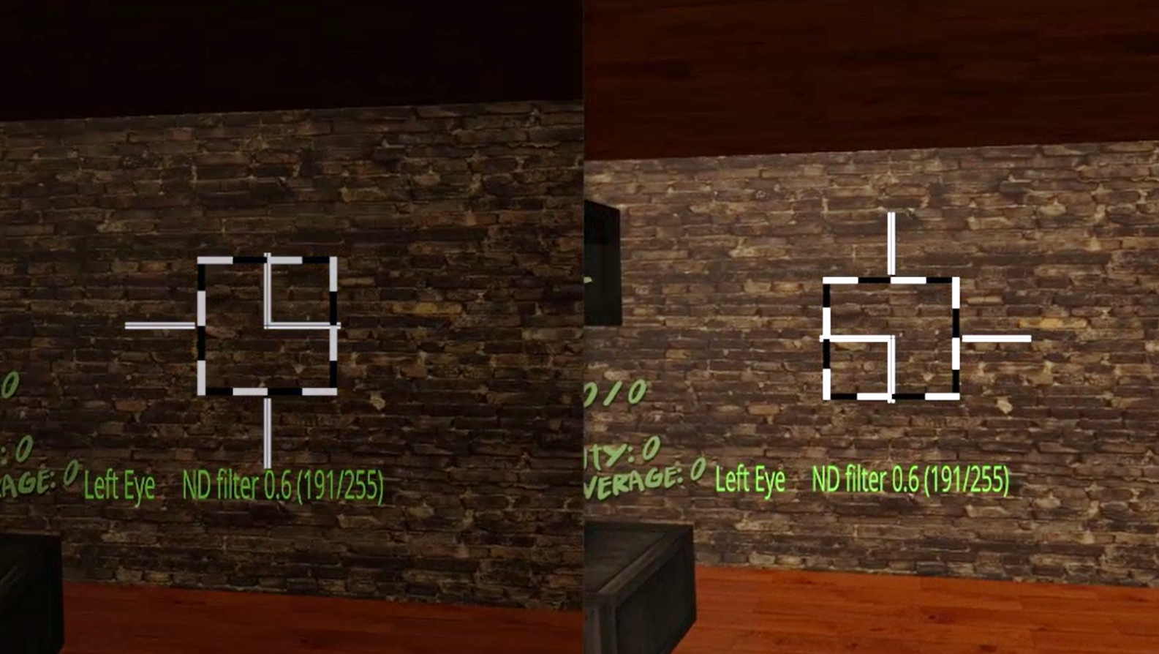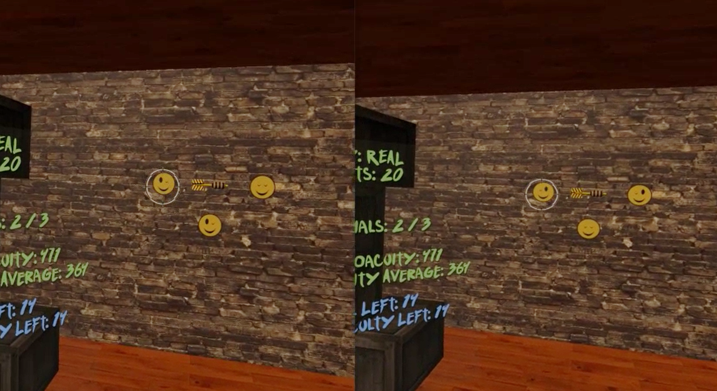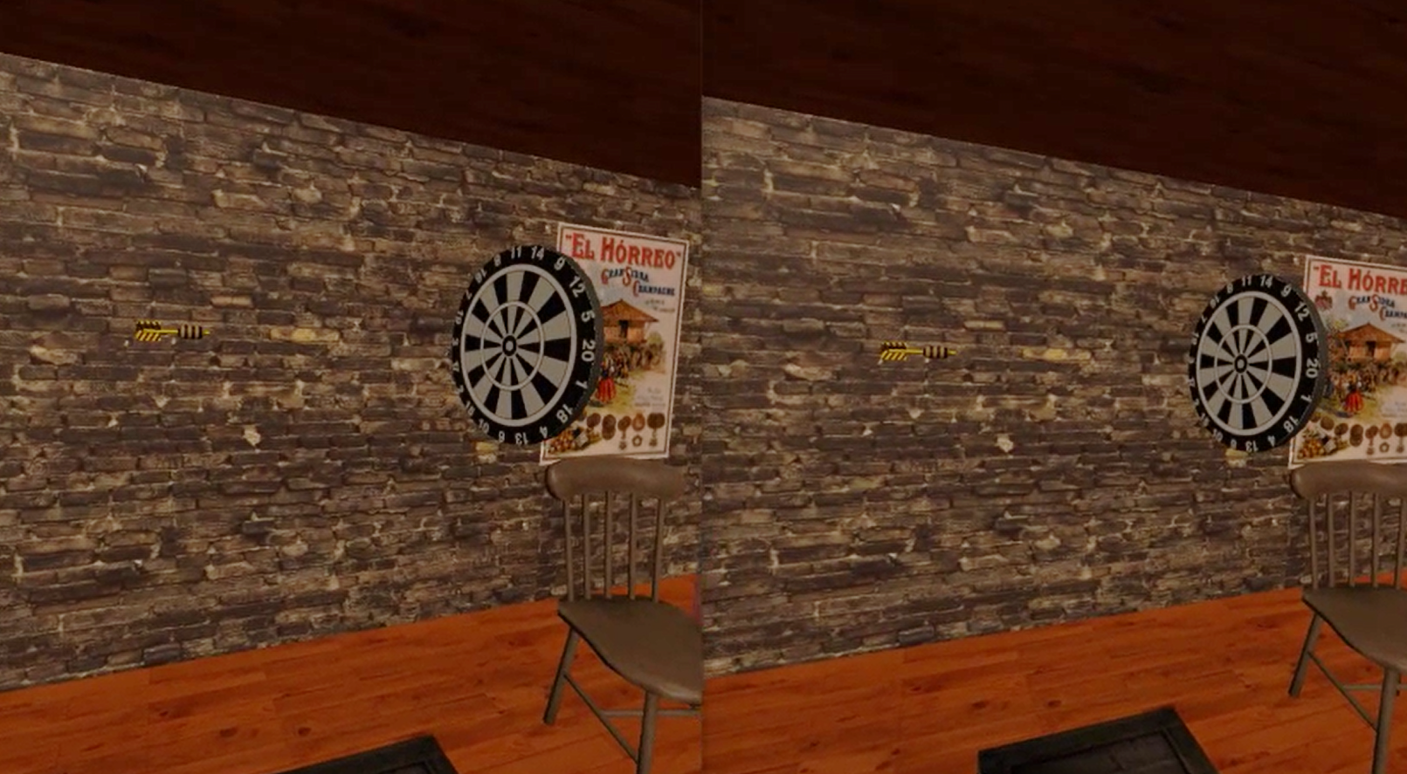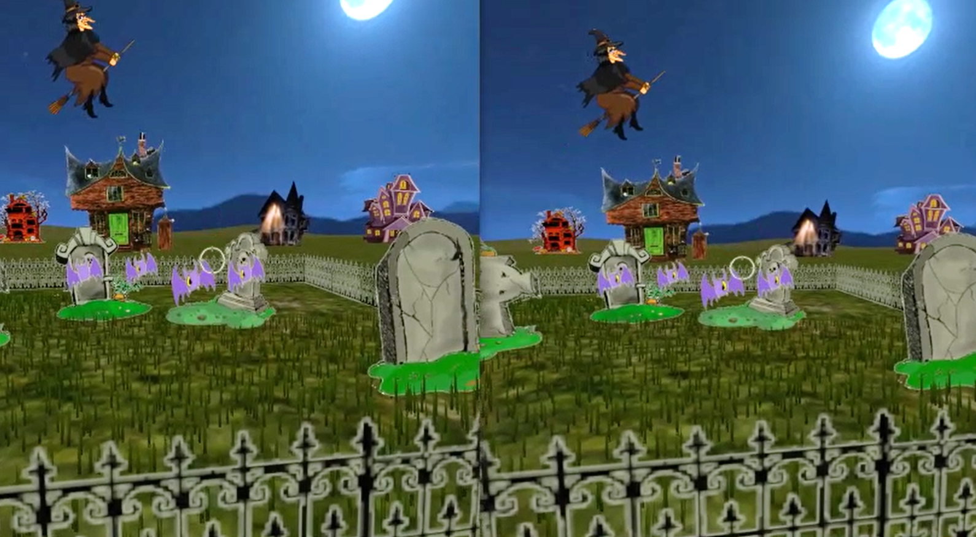

Figure 2. DartBoard and Halloween game screenshots. Top left: Fusion-lock frame calibration for DartBoard (same for Halloween, except the background) to eliminate subjective misalignment angles. Top right: DartBoard 3-AFC suppression test. Bottom left: Example of DartBoard trial. Bottom right: Example of Halloween trial.

Cue scaffolding was implemented in both games, creating three consecutive cues scaffolding conditions (Condition 1, 2, and 3), which progressively eliminate non-stereoscopic depth cues, from an up-to-date VR scene (where accommodation is the only depth cue not simulated) to a scene where only retinal disparity was available. Each session began with Condition 1, which consisted of monocular and binocular cues to depth including shadows, perspective, motion parallax, and binocular disparity. In Condition 2, shadows were eliminated and perspective reduced- meaning, relative size was no longer a reliable cue (i.e., object size was not relative to object distance). Lastly, in Condition 3, motion parallax was limited (only rotational movements of the head were allowed by the software), making binocular disparity the most helpful (almost unique) cue to calculate distance.

A 3-AFC suppression test (by means of dichoptic images) was also inserted in each games’ mechanics to help participants become aware of suppression episodes. For example, in the DartBoard game, participants were instructed to identify the smiley face in a set of three with both eyes open, which could only be seen if binocular fusion was maintained (Figure 2- Top right). In the Halloween game, participants were instructed to eliminate all targets with both eyes open and avoid targets with one eye, which again could only be achieved if binocular fusion was maintained. Importantly, the purpose of the suppression tests was to bring awareness of suppression to participants who actively suppressed. Suppression test failures were registered in both game result files.

Game mechanics and respective in-game measurements were different in each game. In DartBoard, participants were instructed to launch a dart, which was presented at the center of the screen, towards a dartboard that travelled from the back of the participant and moved towards the background of the scene (Figure 2- Bottom left). Each dart launch constitutes a trial. Movement of the dart once launched, was always linear and traveled from left to right, while movement of the board was linear, but not necessarily at a 90° angle or at the same speed of the dart. Both linear movements occurred in the same plane where the observers’ eyes were. Thus, there was no way of guessing the intersection of both trajectories using monocular cues. The movement of the dart board was designed to stop at intervals in order to facilitate the exercise. The perceptual learning task for the participant was estimating, using the background wall as reference, when the dart (stationary object) and the dart board (object moving in depth) were at the same distance (i.e. accuracy could theoretically be as low as zero arc secs). In Halloween, the participant was instructed to shoot the closest target in a variable set of targets (three to seven phantoms, pumpkins or vampires) as they approached the participant (Figure 2- Bottom right). Each shoot constitutes a trial. Similar to the movement of the dartboard, the approaching targets stopped at intervals to facilitate the exercise. Importantly, relative parallax between the targets were constant, and decreased across trials from 1000” to 400” over time, depending on the participants’ performance. Therefore, the perceptual learning task in Halloween was to determine the relative distance between several objects. It is important to note that DartBoard in-game measurements result in accuracy threshold values for each trial at each cue scaffolding condition; while Halloween in-game measurements result in the proportion of correct responses for each stereo demand at each condition.